Preliminary discussion (foundation, framing, window orders)

Layout (walkthrough)

Kitchen:
Pantry
Ceiling:
Upstairs closet (impact on kitchen ceiling)
Upper cabinets soffit
Arch window finish

Interior arches (photos provided by Sauerhoffs):
Kitchen / great room, great room / dining room, and front hall transitions
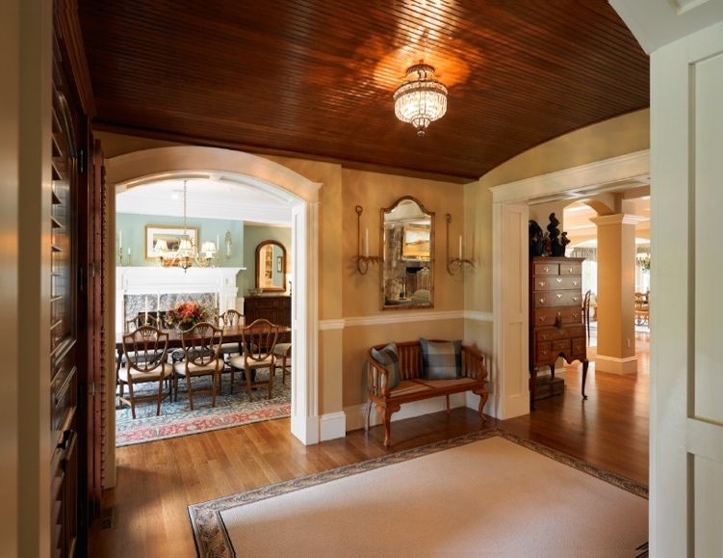
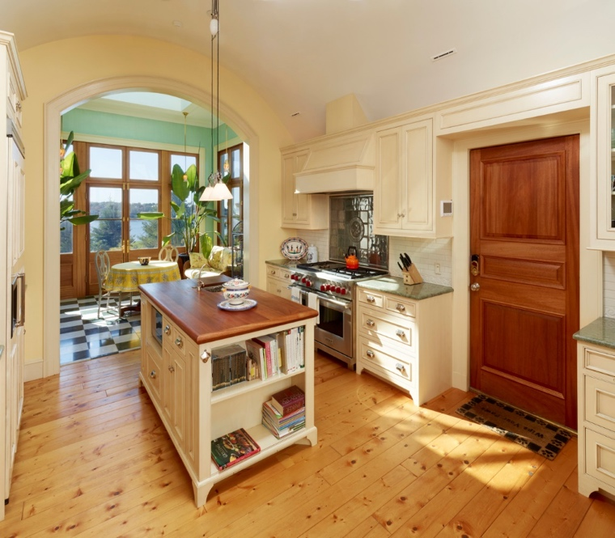
Terrace arch (see mock ups)
Siding color and roofing shingle color (see samples and mock-ups for final approval)
Sample colors provided by BG mock-ups and Sauerhoffs’ selections

Roof layout (walkthrough)
Note: interior walls installed following installation of radiant tubing / mechanical install into floors

Landscaping (preliminary / walk property)

Next phase / looking ahead (updated schedule)

FINAL, 5/24/24

